PDF Generation and compression for EEE Final Reports

Some pictures can be quite large in size, especially if embedded at very high resolution:

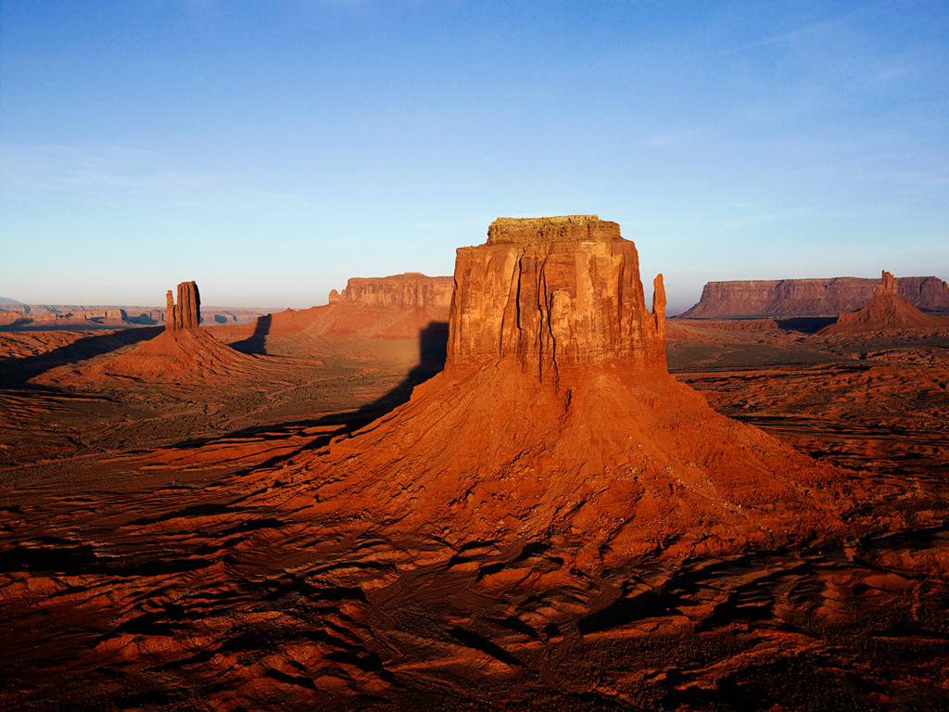

Word documents can normally be saved as PDF. This needs to be checked since sometimes unusual embedded objects cause problems. Otherwise they can be printed with a PDF printer. Again, there can be problems so check this.

Document size is dominated by embedded pictures. The above picture controls this document’s size as follows

**Word**

(1)

* Docx – 840k
* PDF (normal) 217k
* PDF (online) 120k

(2) JPG graphics can be compressed (very important when cropped pictures are used) from the:

Select picture->Picture tools->format->compress dialog

You should normally compress all graphics removing cropped content before saving to PDF.

**Latex**

Use pdf generation options to reduce jpg resolution and increase compression. Again, beware graphics that are highly cropped but stored with all original information.